Computer Networks (CS303)

Practical Exam

**U19CS012**

Problem Statement:

Q1. Create a network topology in Cisco packet tracer. (20 Marks)

Add minimum 5 systems and one server

Configure below services on the server

**1. DNS**: Provide domain name and modify index.html page on server

Expected output:

● nslookup <domain name> command in command prompt of any pc should show

server ip address

● Web browser of any pc should be able to open index.html page

**Config the Server**

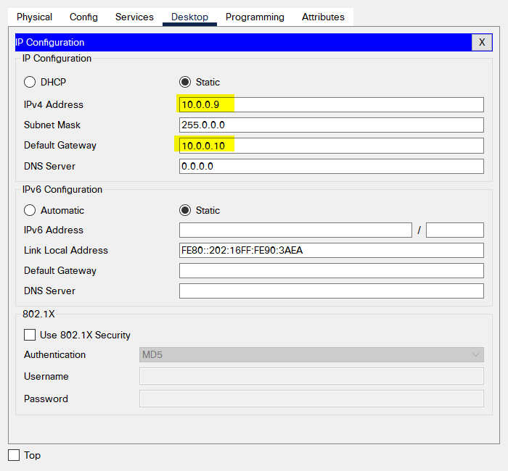

**Config the Router**

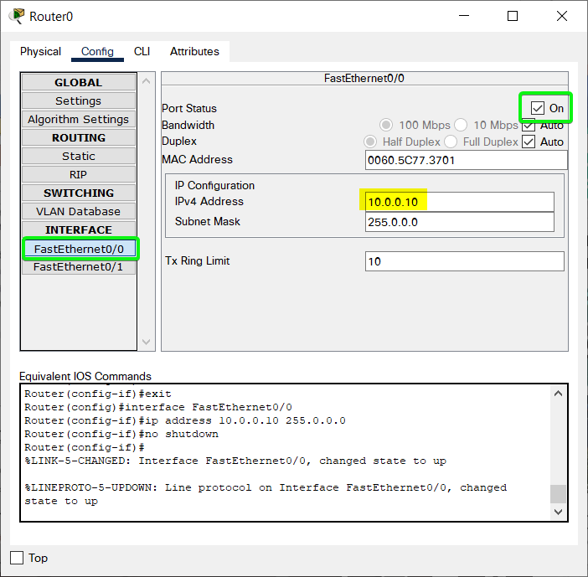

**Config the End Devices**

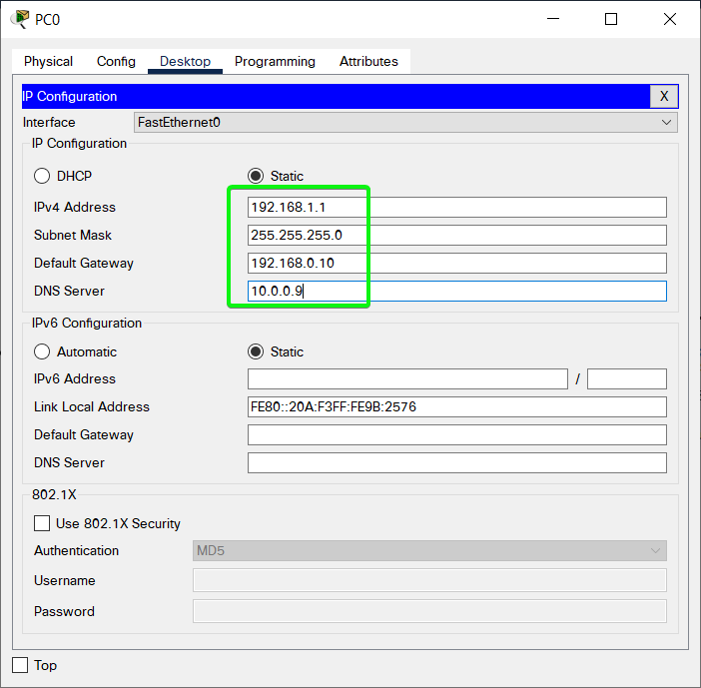

**Service in Server**

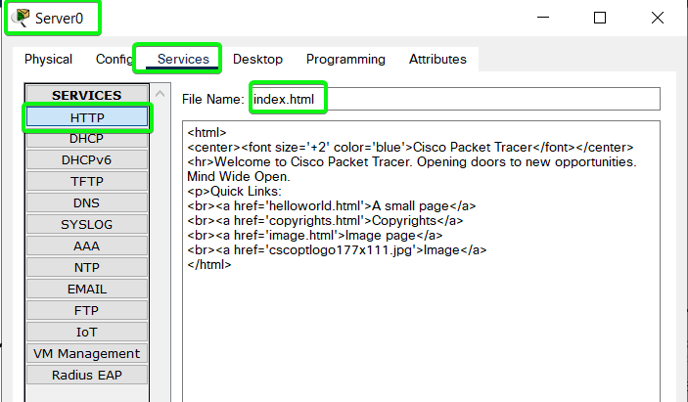

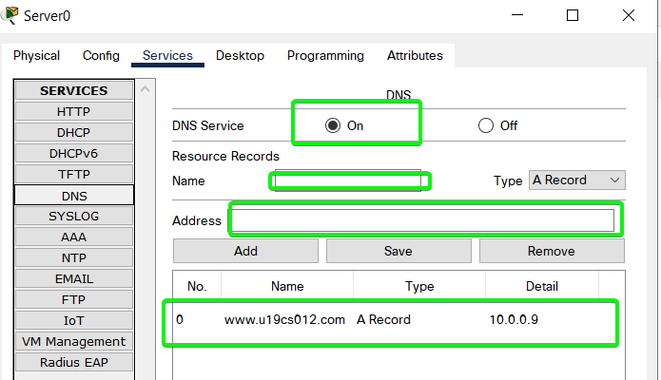

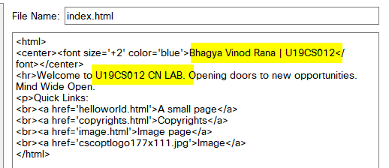

**Go to Any End Device and in Web Browser**

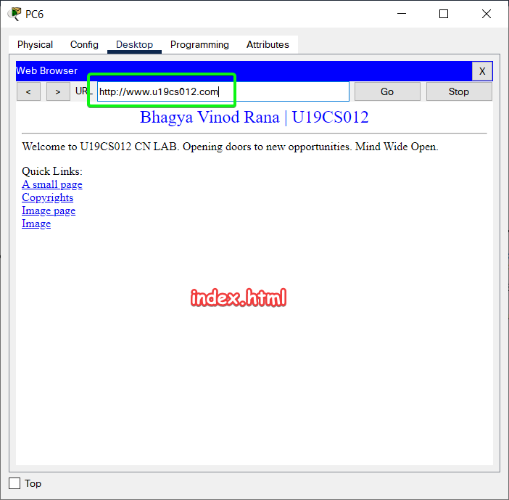

**2. Email**: Configure Username, Email id, login details etc in 2 pc’s. Configure Email service

on server also.

Expected output:

● Mails should be sent and received between systems in which Email

configurations are done.

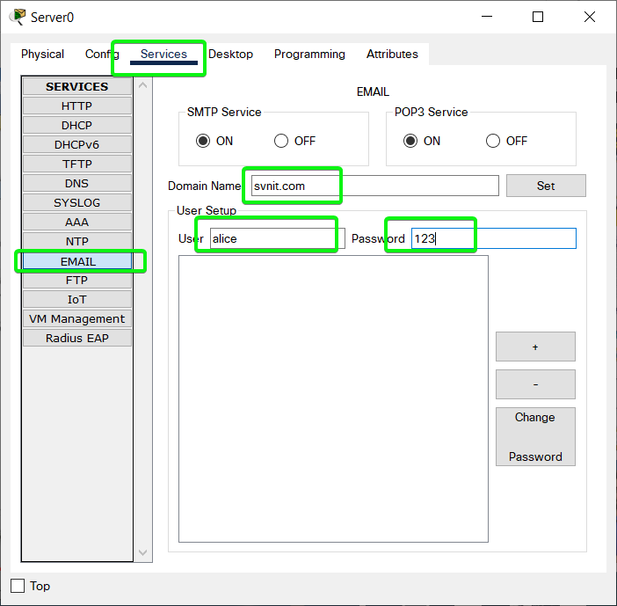

Similarily add bob

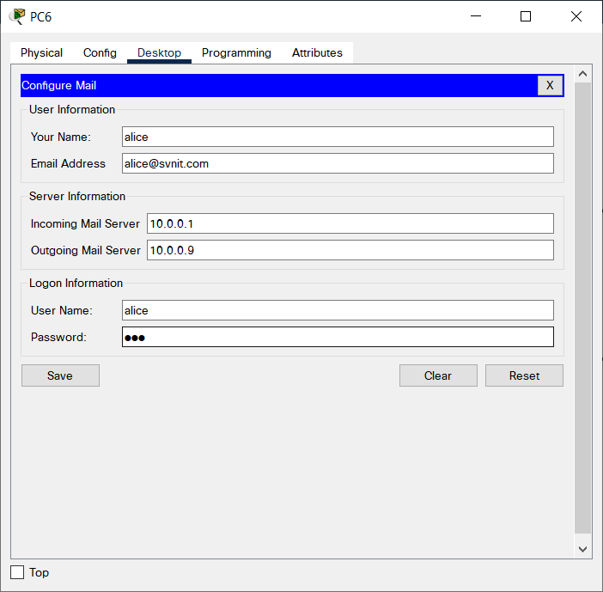

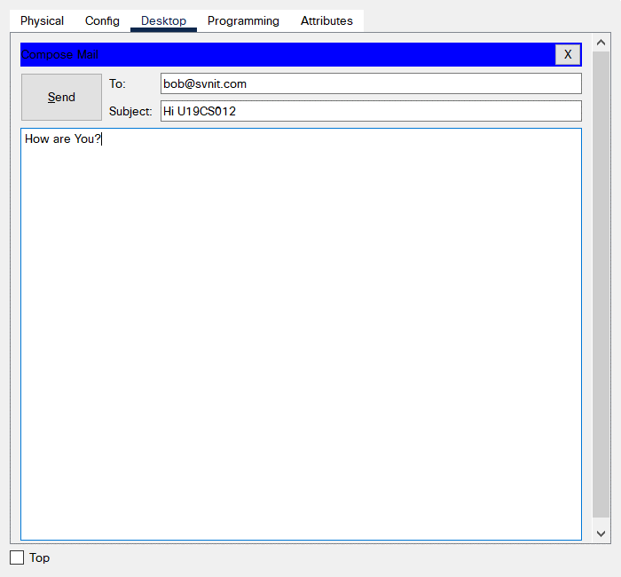

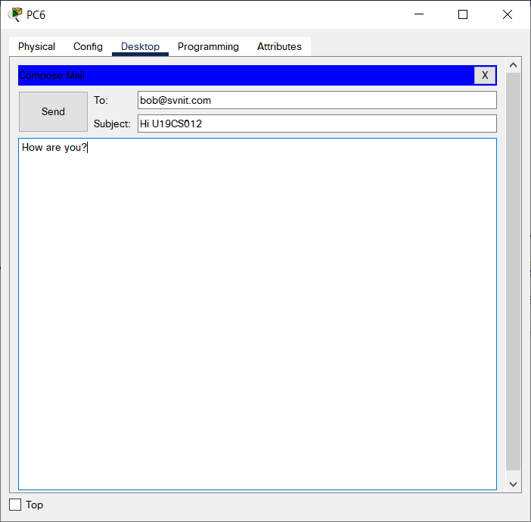

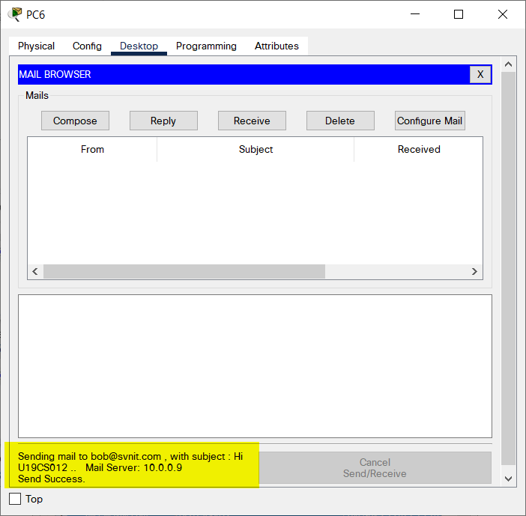

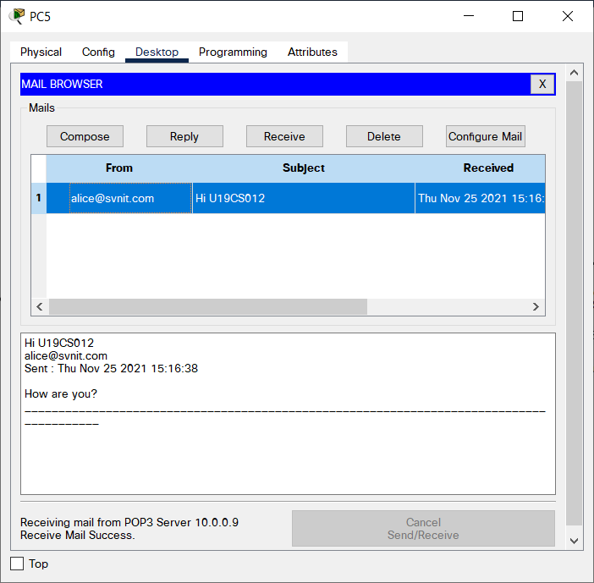

**3. FTP**: Configure FTP on server.

Expected output:

Create one text file( eg test.txt) on any of the pc ( Eg PC0). Connect to the server

from the command prompt of PC0 and UPLOAD test.txt file on the server via

FTP.

Connect to the server from the command prompt of any other PC except PC0

and DOWNLOAD test.txt file on the server via FTP.

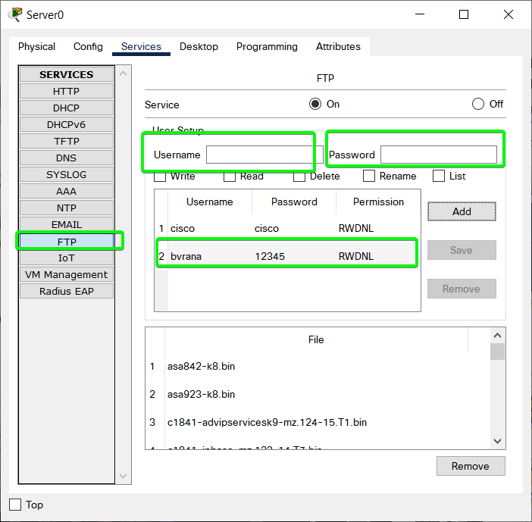

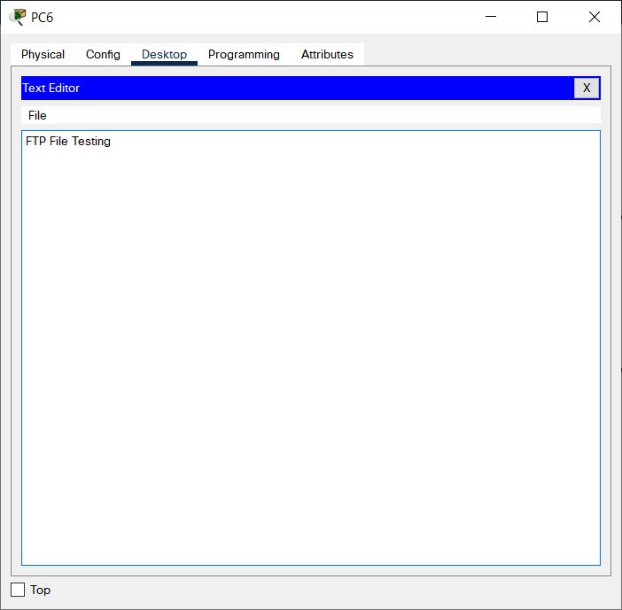

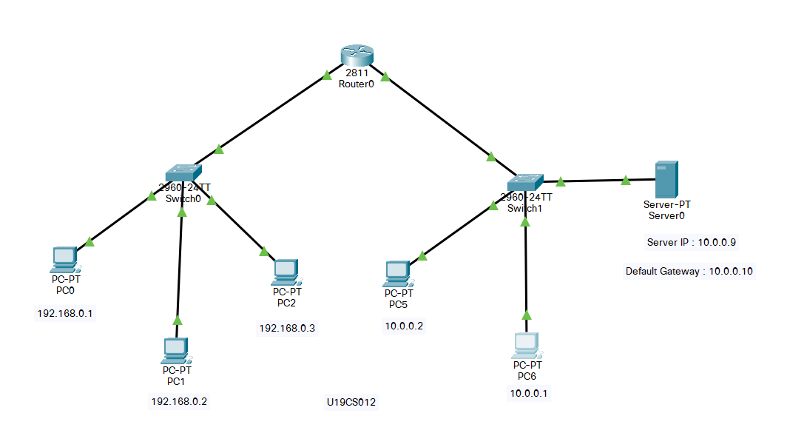

SUBMITTED BY:

**U19CS012**

BHAGYA VINOD RANA